Youngbin Pyo ID:906958

Assignment 4

Question 1

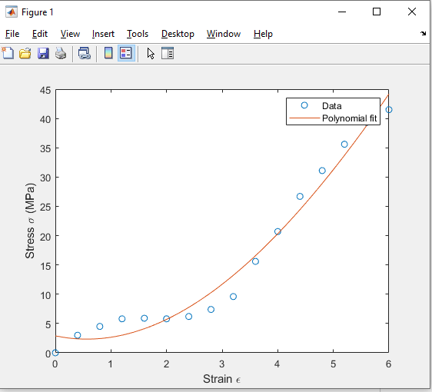

Question 2

A=26.339538402738405

B=(-)31.657671088819772